Pandas Series & DataFrames

🔹 Reminder
Yesterday we learned NumPy arrays → efficient numerical data storage and manipulation.
👉 Pandas builds on NumPy to handle tabular/labeled data (like Excel tables).

🔹 Introduction to Pandas

🐼 How Pandas is Related to NumPy

1. Pandas is Built on Top of NumPy
- Under the hood, Pandas stores data in NumPy arrays.
- Every Series(1D labeled array (like an Excel column)) in Pandas is basically a wrapper around a NumPy ndarray with labels.
- A DataFrame is just a collection of Series objects, which means → lots of NumPy arrays working together.

2. Shared Operations
- Both Pandas and NumPy support vectorized operations (fast, element-wise math without loops).
- Many Pandas methods actually call NumPy functions internally.
Example: df.mean() → uses numpy.mean().

3. Differences
Feature | NumPy | Pandas
Main Object | ndarray (n-dimensional array) | Series (1D) & DataFrame (2D)
Data Types | Homogeneous (all elements must be same type) | Heterogeneous (different columns can have different types)
Labels | Only integer indices | Row & column labels (names)
Use Case | Numerical computation | Data analysis / tabular data

Use in Data Science
Almost every dataset in data science is loaded into a DataFrame before analysis.

🔹 Pandas Series

Notes
- Series = one column of data, with an index.
- Can be created from lists, NumPy arrays, or dictionaries.
- Supports slicing, indexing, and operations like NumPy.

Practical 1 – Creating a Series
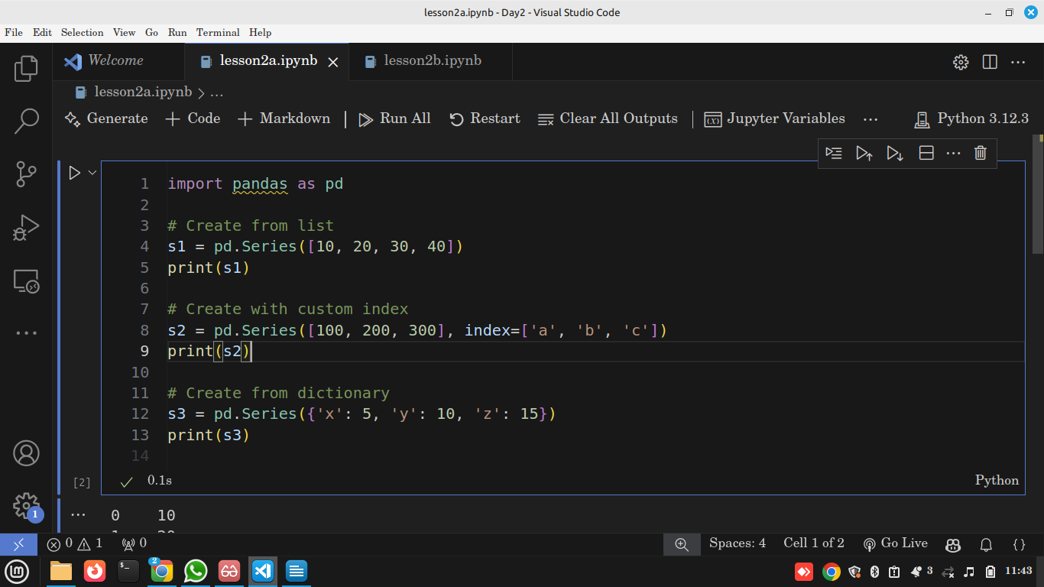

Output
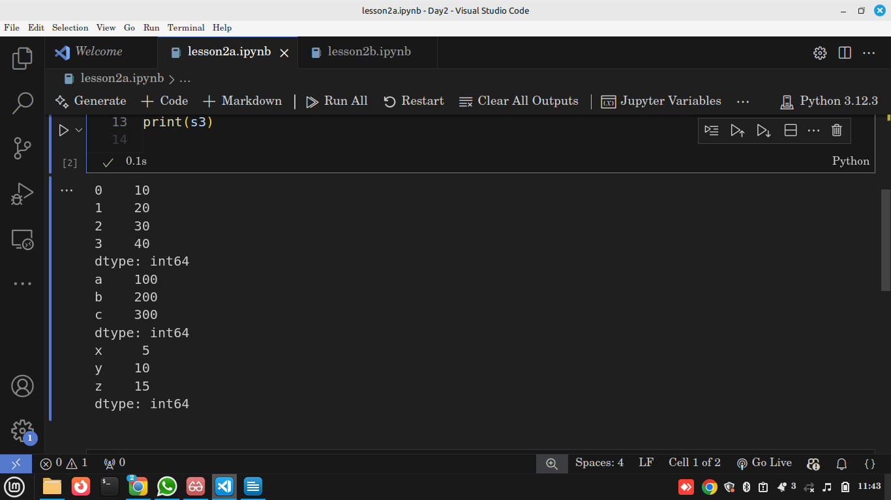

Explanation
- pd.Series(list) → creates a Series with default integer index (0,1,2...).
- index= lets us name rows (like Excel row labels).
- A dictionary automatically maps keys → index.

Use in Data Science
Series often represent a single variable (like "Age" column in Titanic dataset).

Practical 2 – Indexing and Slicing
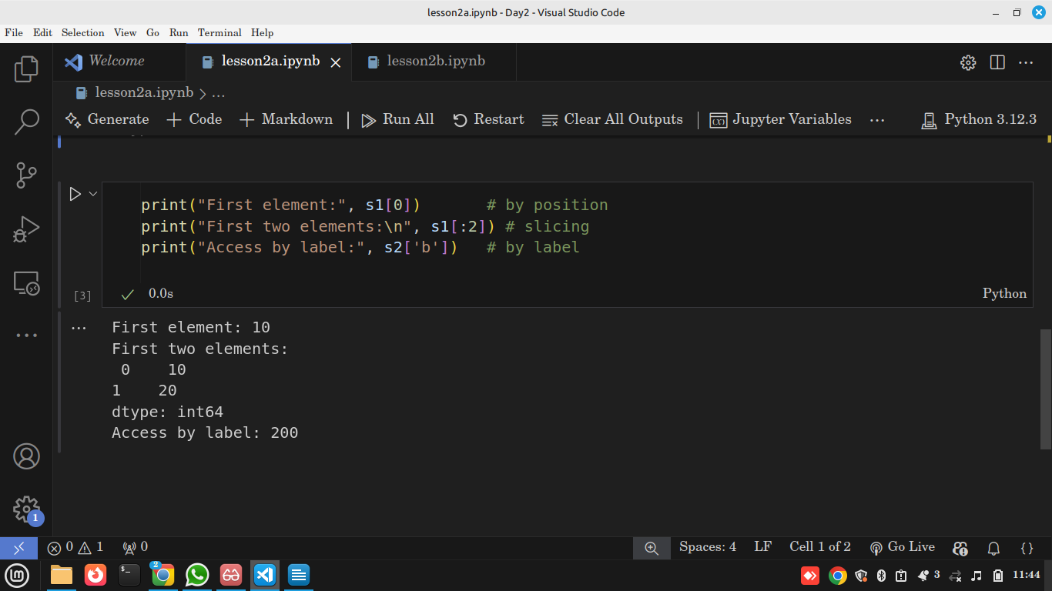

Explanation
- Access by position (like NumPy arrays).
- Access by label if index is custom.
- Slicing works like Python lists.

Use in Data Science
Lets us extract specific rows or ranges for analysis.

Practical 3 – Operations
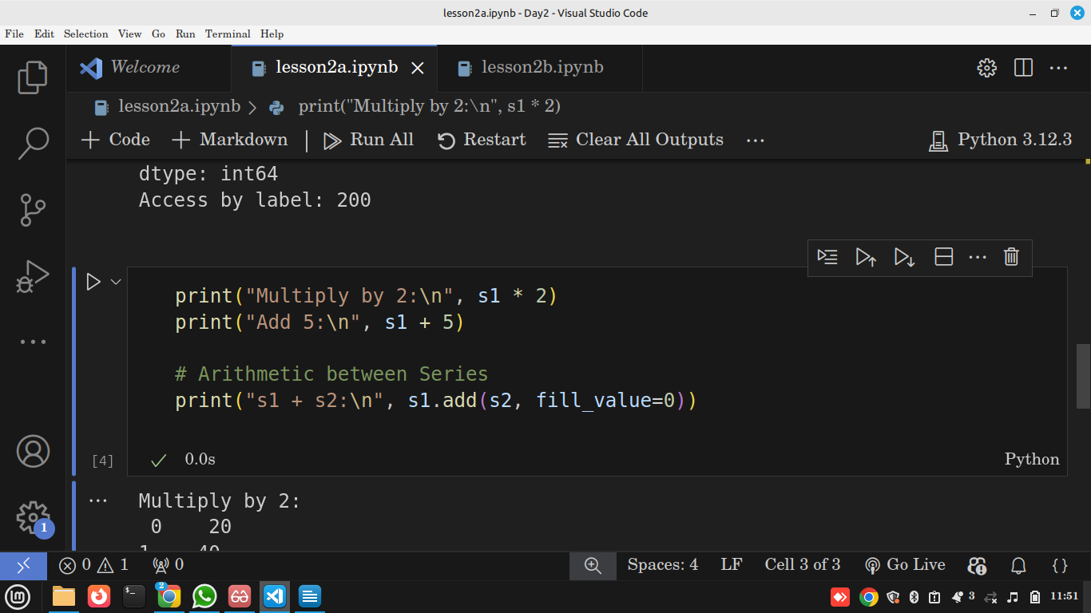

Output
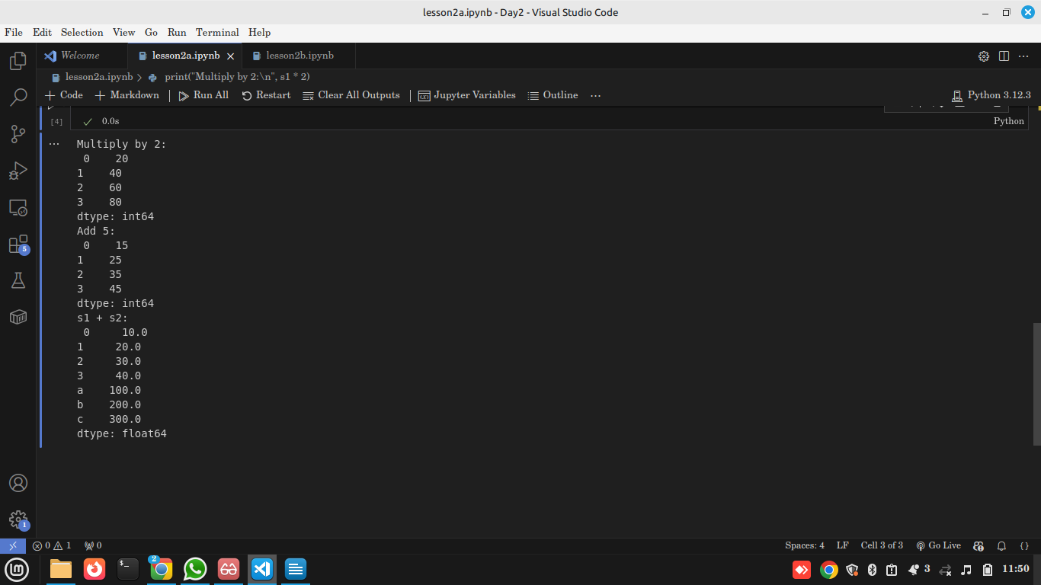

Explanation
- Operations apply element-wise.
- When adding Series with different indexes, Pandas aligns by index.
- fill_value=0 fills missing values before arithmetic.

Use in Data Science
This makes data transformation vectorized & efficient compared to Python loops.

🔹 Pandas DataFrames

Notes
- A DataFrame is a collection of Series (columns).
- Think of it as a table: rows + columns.
- Can be created from dictionaries, NumPy arrays, or files (CSV, Excel, etc.).

Practical 1 – Creating a DataFrame
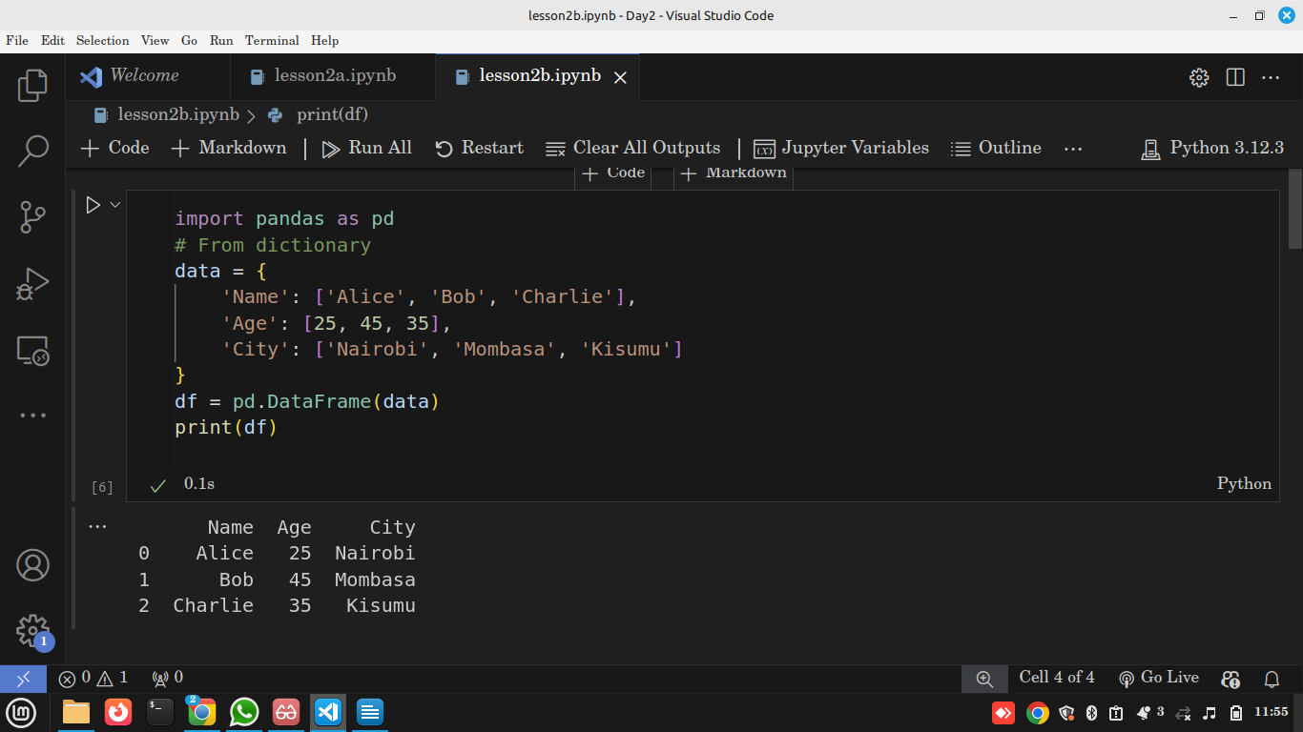

Explanation
- Each key in dict → column name.
- Each list → column values.
- Output is tabular, with row and column labels.

Use in Data Science
DataFrames are the standard way to store datasets for analysis.

Practical 2 – Inspecting Data
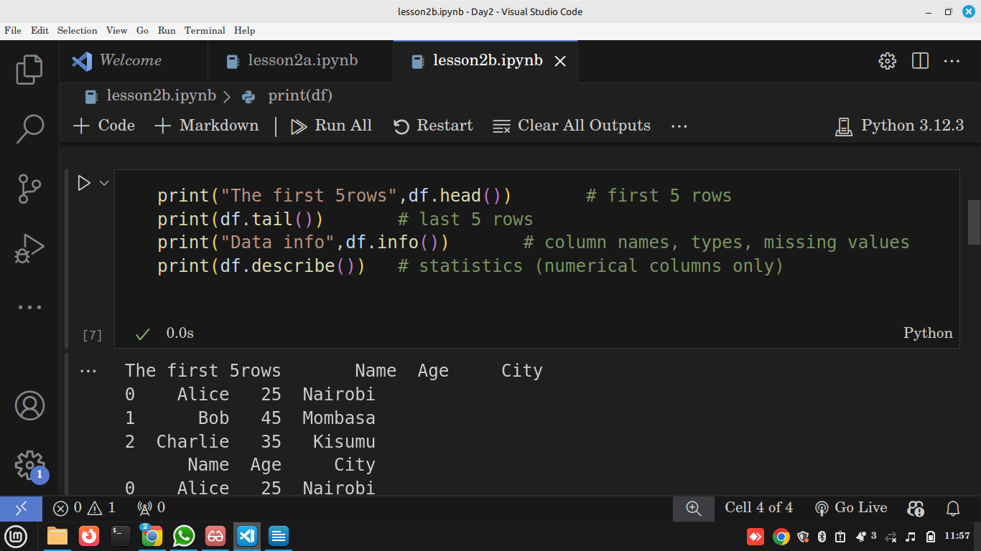

Explanation
- .head() and .tail() → quick dataset previews.
- .info() → useful for checking data types & null values.
- .describe() → summary statistics.

Use in Data Science
These are the first commands analysts run after loading a dataset.

Practical 3 – Accessing Columns & Rows
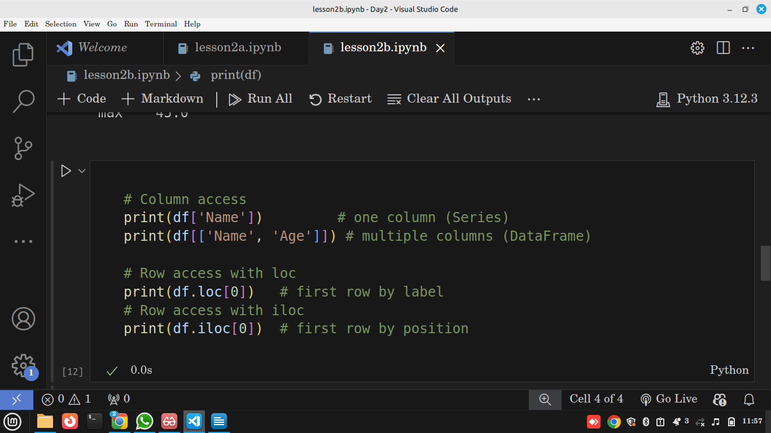

Output
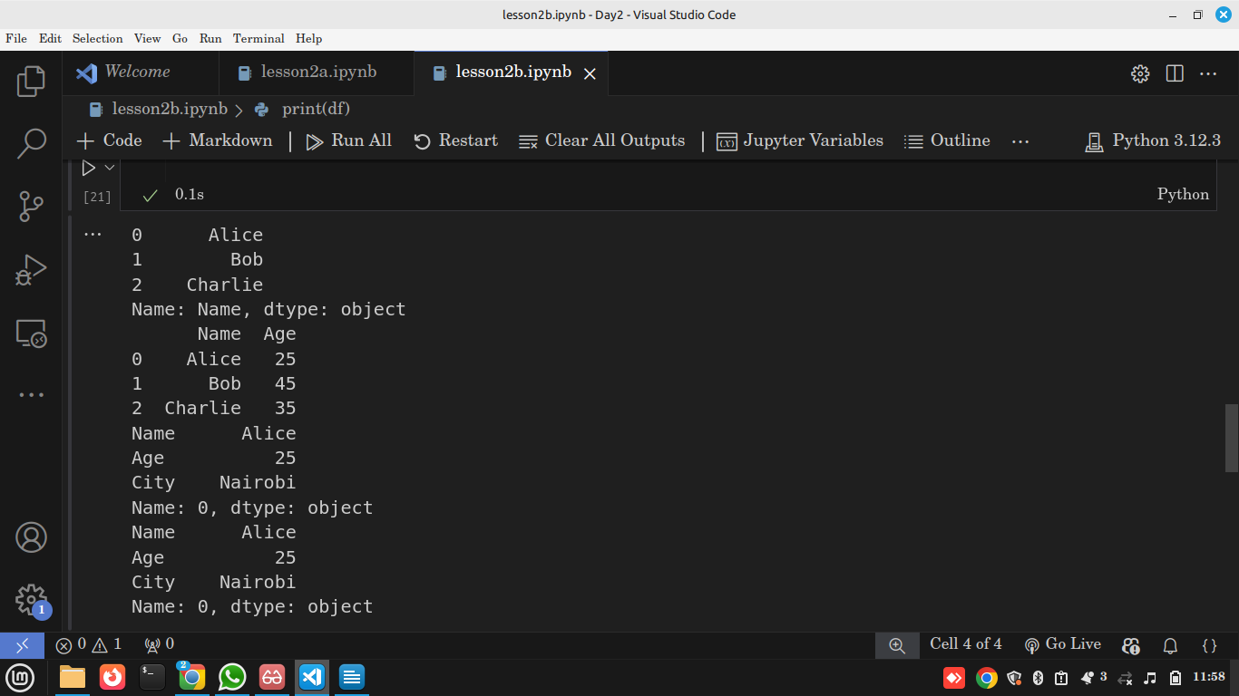

Explanation
- Single column = Series.
- Multiple columns = DataFrame.
- .loc → label-based indexing.
- .iloc → position-based indexing.

Use in Data Science
Lets us select subsets for analysis (e.g., only numeric columns for statistics).

🔹 Indexing: loc vs iloc

Notes
- .loc[] → label-based (row/column names).
- .iloc[] → integer-based (row/column positions).

Practical
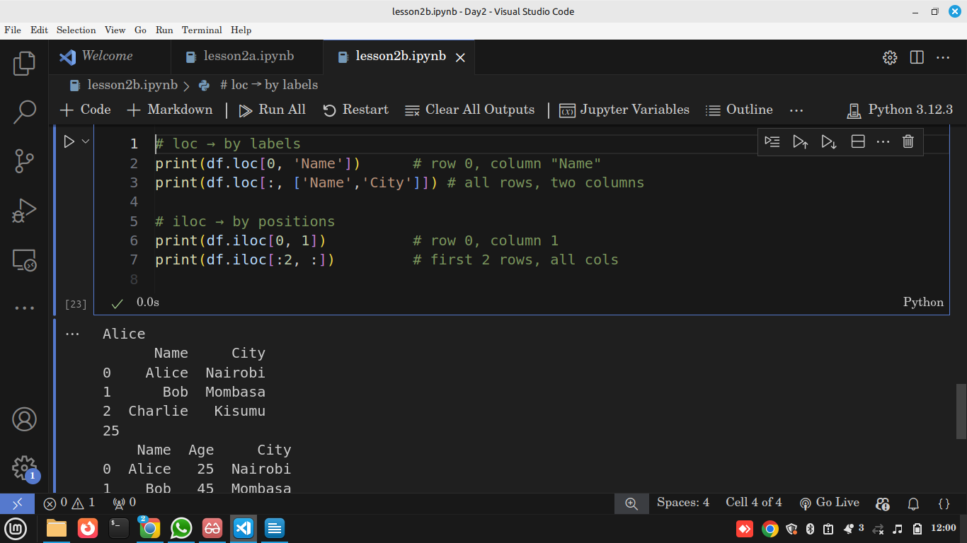

Explanation
- .loc[0, 'Name'] → fetches "Alice".
- .iloc[0, 1] → fetches first row, second column (Age = 25).

Use in Data Science
Used heavily in subsetting datasets for training/testing ML models.

🔍 Reflection
Why are DataFrames more powerful than NumPy arrays?

